

**FPT UNIVERSITY**

**--o0o---**

**Project Report:**

**WEB - FanOFan**

Member: 1. Nguyen Dinh Hieu

2. Vu Quang Huy

3. Le Thanh Tung

4. Pham Tuan

Faculty: Dang Kim Thi

***Table of Contents.*** Page

1.Introduction 2

2.Customer expectations 3

3. User stories 4

4.Flowchart 5

4.1 Search Products 5

5.Photo Of Website 6

5.1,Home 6

5.2,Product-list 7

5.3,Product-detail 8

5.4,Pay 9

5.5,Credit Card 10

5.6,Paypal 11

5.7,Bank Transfer 12

5.8,About 13

5.9,Store-list 14

5.10,Support 15

5.11,Sign in 16

5.12,Sign up 17

5.13, Forgot Password 18

6.Summary 18

1. **INTRODUCTION**

We have a team of 4 people who have created a website to sell fans. You know that with the current 4.0 trend, most people will buy on the website more. So we created A website that addresses consumers' problems is a website that sells high-end ceiling fans. Here you will be introduced to high-quality fans and meet the needs of consumers. I also create checkout pages that make it easy to order and buy the fans you like. We create user interaction with the website so that users can use them easily and The websites are linked together consistently and can be used in any type of website devices such as laptops, tablets, phones, and websites also run smoothly on applications such as Chrome, IE, Firefox, etc.  
This website will be developed for Windows Platform with HTML5, CSS, javascript, jquery, bootstrap, etc.  
The website will be created based on the following requirements:  
1) The Home Page should be created making use of Sections with a suitable  
logo, the header section can be added which will show images Fans.  
2) The site must contain the links to navigate through any category for the  
information.  
3) Links of bottles can be categorized like (Ceiling Fans, Table Fans, Exhaust, etc.)  
4) Specification and Pricing of Fans can be added along with the images.  
5) The gallery section can be added for viewing different images.  
6) Feedback must be allowed to enter by the viewer  
7) The site map, Gallery, about us, Queries link, Contact us link must be added.  
The address of the Company should be displayed using the GeoLocation API (eg.  
GoogleMaps).  
The complete description must be allowed to get download as pdf or doc file.  
9) The advertising section with various facilities provided should be mentioned.

**2. Customer expectations:**

AutoWorld.com needs to be built according to the following requirements:  
1. The homepage will briefly introduce the company, also design the appropriate logo and put it on the homepage, you can display the logo on every page of the site.  
2. A menu will include all the functions performed on the website.  
3. A list should be provided to help the user to look at the image of the fan and click on the same thing will show details about it. The details include features, prices, specifications, etc.  
4.Need to have a page to contact the company that will include your address, phone, and email address. Company addresses must be displayed using the GeoLocation API (for example, GoogleMaps) and the email address when clicked will call the local mail client from where they can send an email.  
5. The web page also includes a support page to support customers with products, customer suggestions and support customers with warranty.  
6.Need to have a page that will list large stores with full information such as company name, address, phone number, introduction to the store  
7) The website should also include a comparison of different fans (like different brands).  
8. Users will be able to search for fans based on companies and prices.  
9. Information about different fans can be selected from the internet.  
10. The website must have an appropriate interface and be consistent with the reputation and position of the company.

**3. User stories**

User type (Example: Customer)  
Story 1: See  
Customers can view all interesting information from product news, product specifications, after-sales service, storage, comparison and contact with the Group by selecting what customers need to see. to respond as widely as:  
- Are our latest fan models available?  
- What are the salient features of 'FanOFan'?  
- Fan price list.  
- What about the warranty/warranty of the fan?  
- Which type of fan is better than any?  
- What are the available payment methods?  
Story 2: Searching  
Allows users to search and filter information to see only the information of interest in the price range or choose by fan brand by sorting the price or selecting the fan launch time. The website will respond according to the formation of search criteria such as sorting by price, brand or the latest production fan.  
  
Story 3: Compare  
  
Customers can compare fans with the same price but different brands with different features to suit customers' requirements by choosing models of 2 different brands. The site will respond to all specifications for customers to choose the right one for their needs.

**4. Flowchart**

**4.1 Search Products**

Start

Enter keyword

Not Fount

Search

Found

Display Result

End

**5. Photo Of Website**

5.1,Home

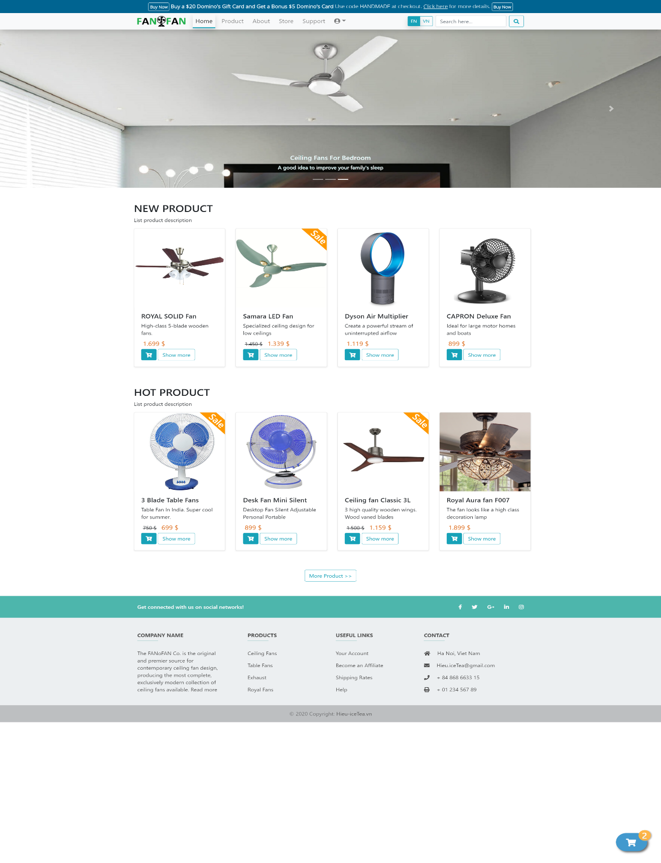

5.2,Product-list

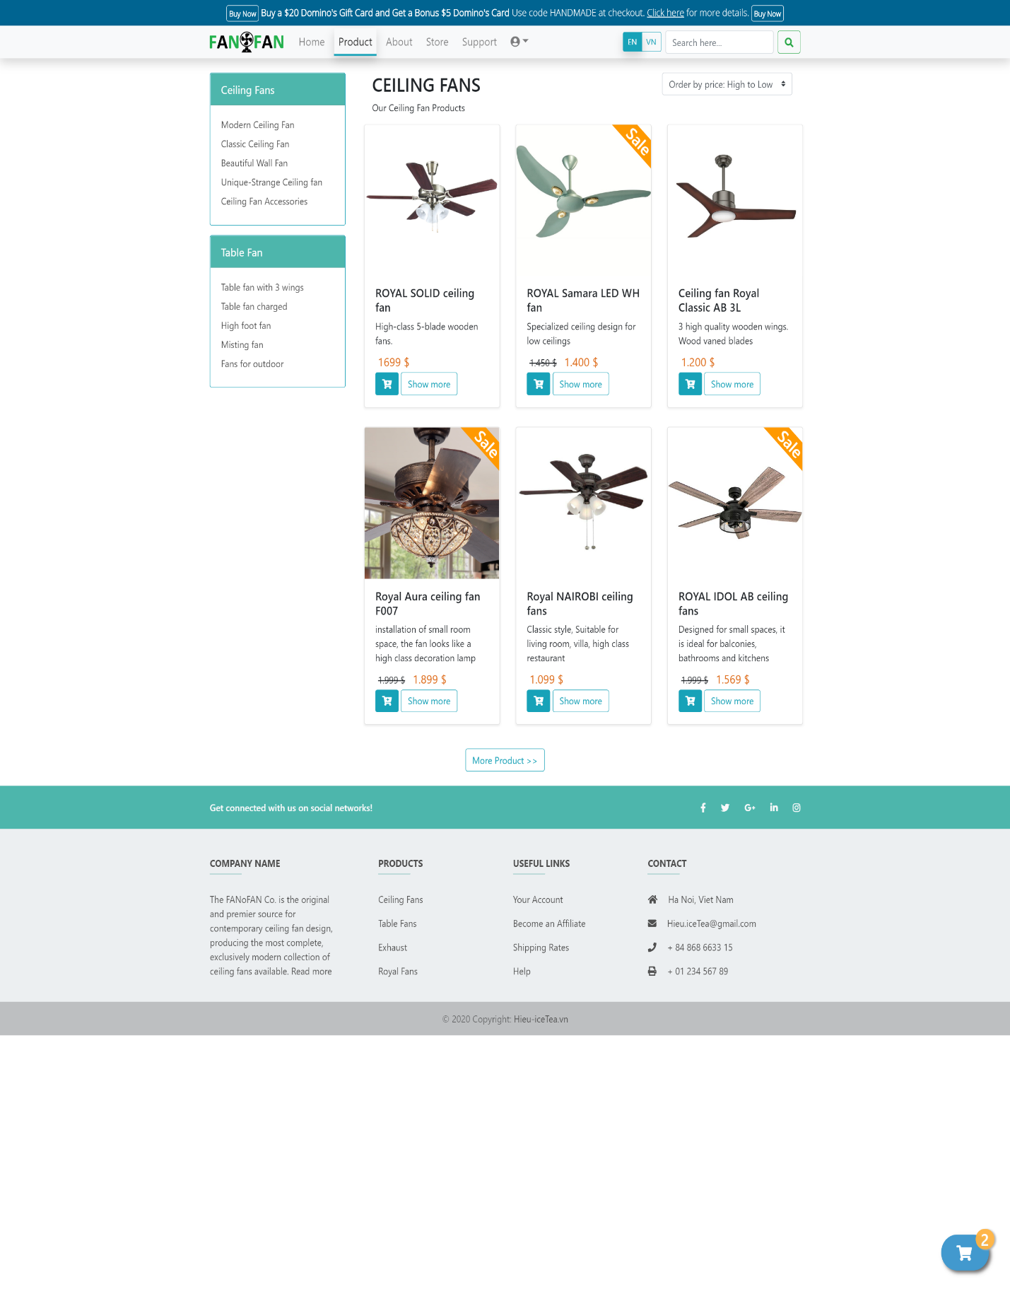

5.3,Product-detail

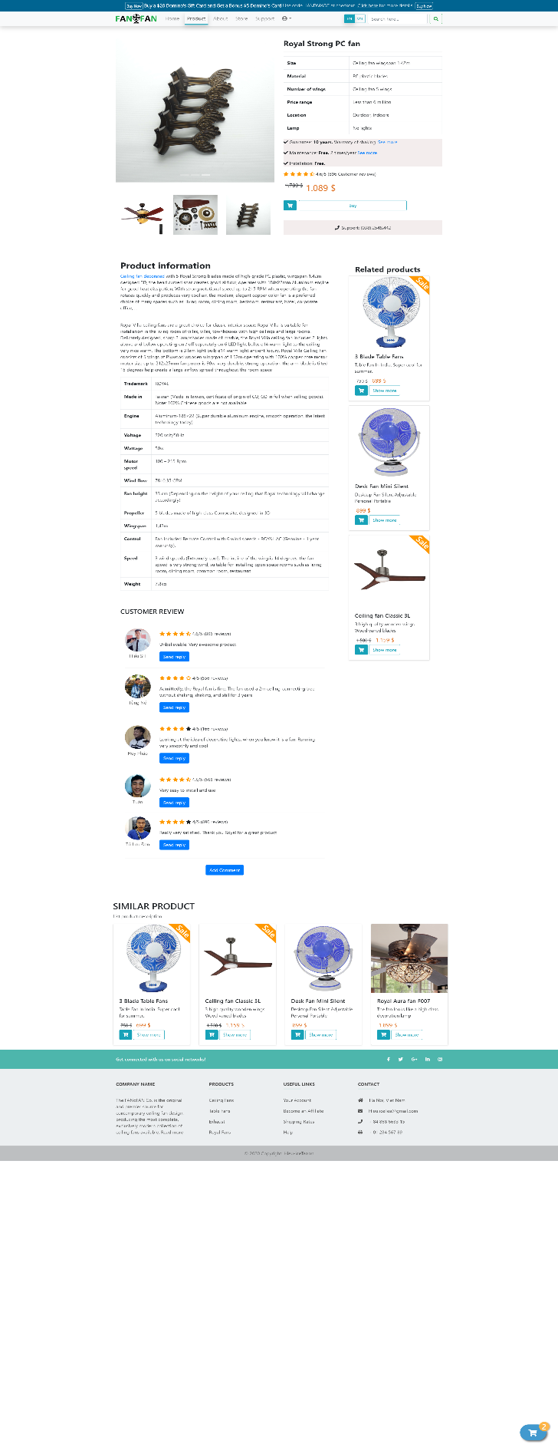

5.4,Pay

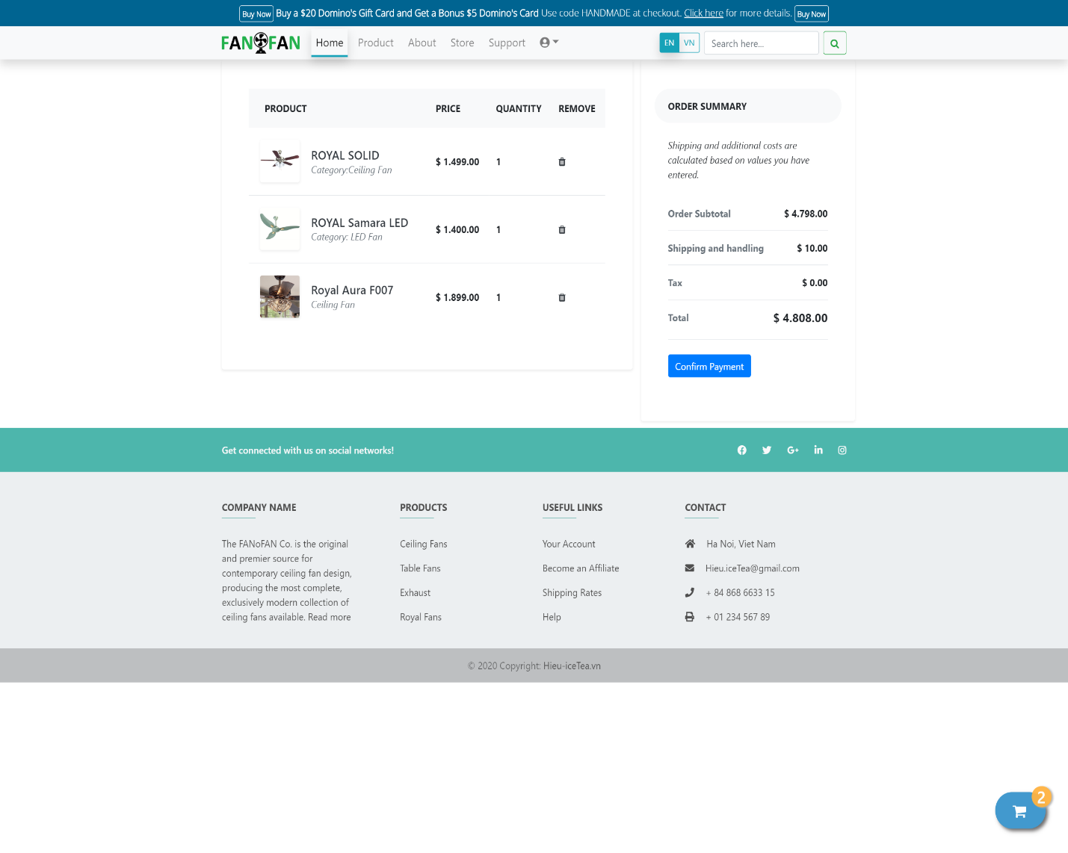

5.5,Credit Card

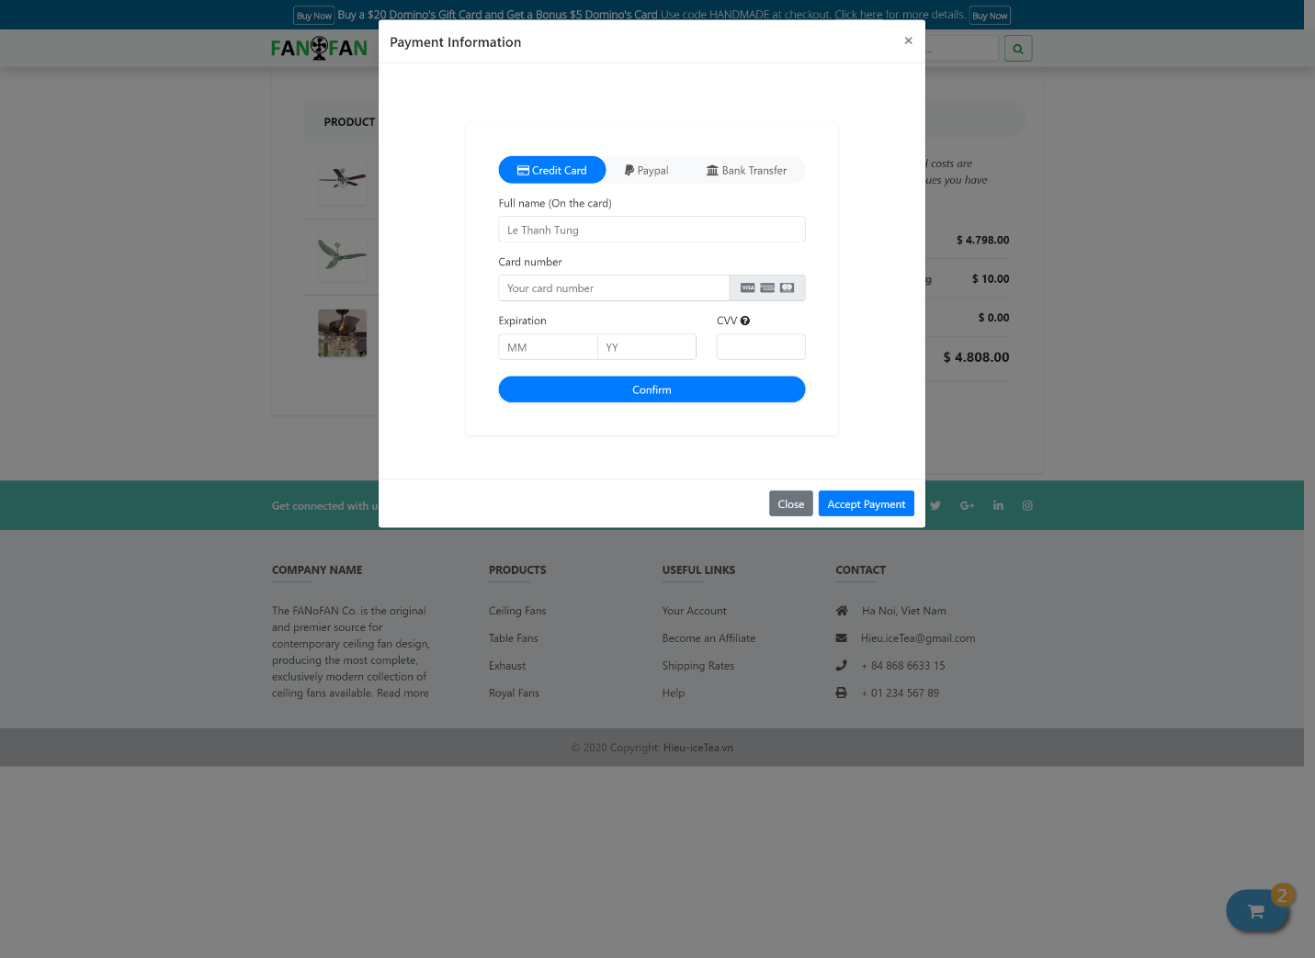

5.6,Paypal

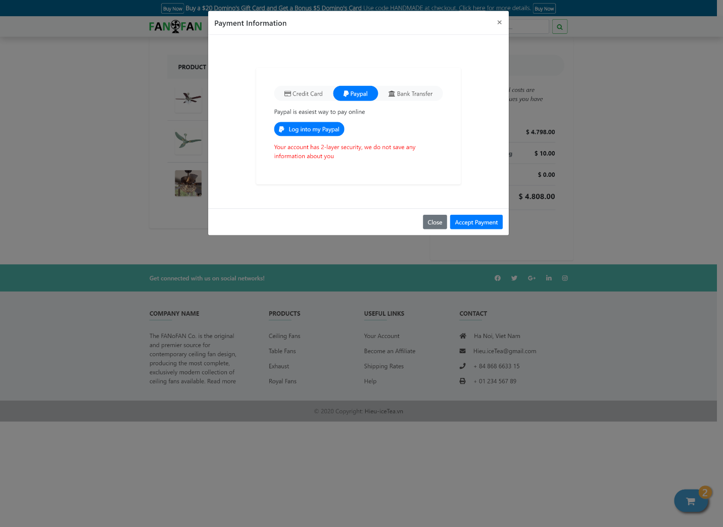

5.7,Bank Transfer

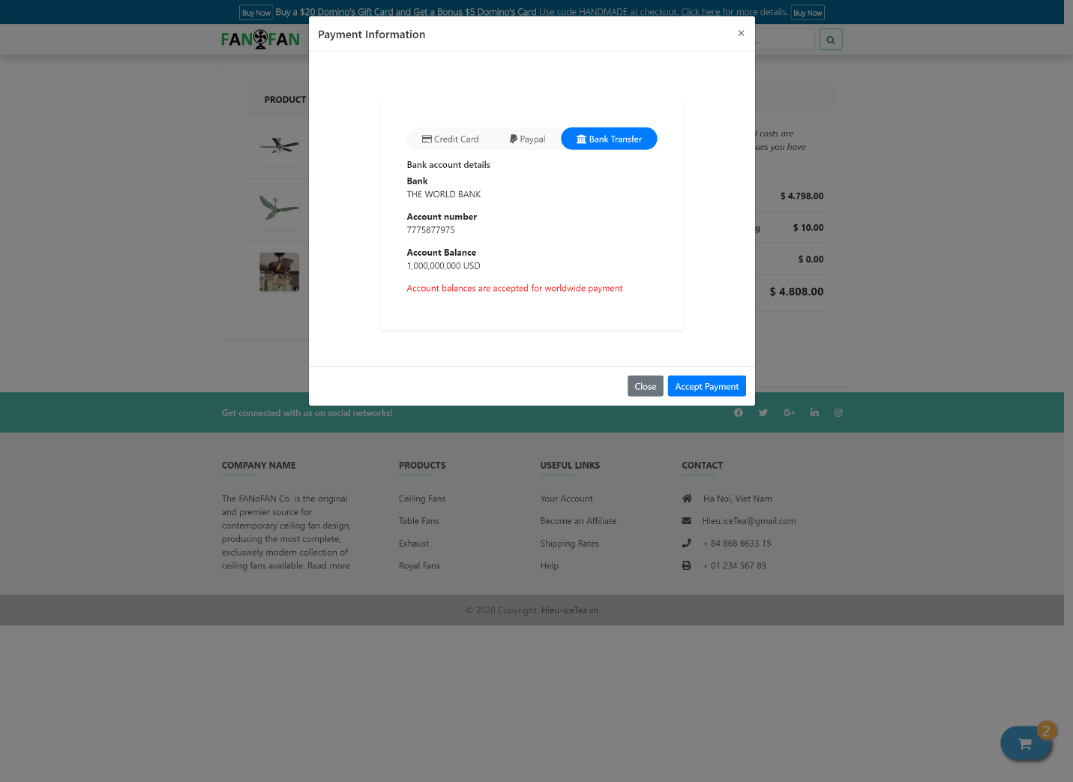

5.8,About

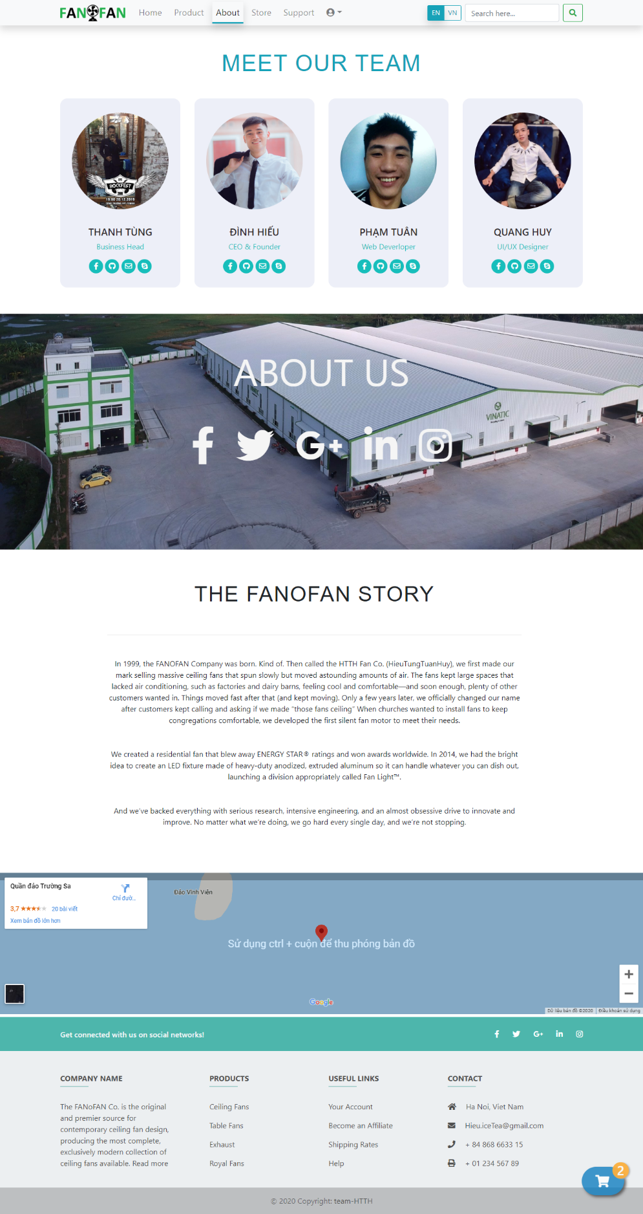

5.9,Store-list

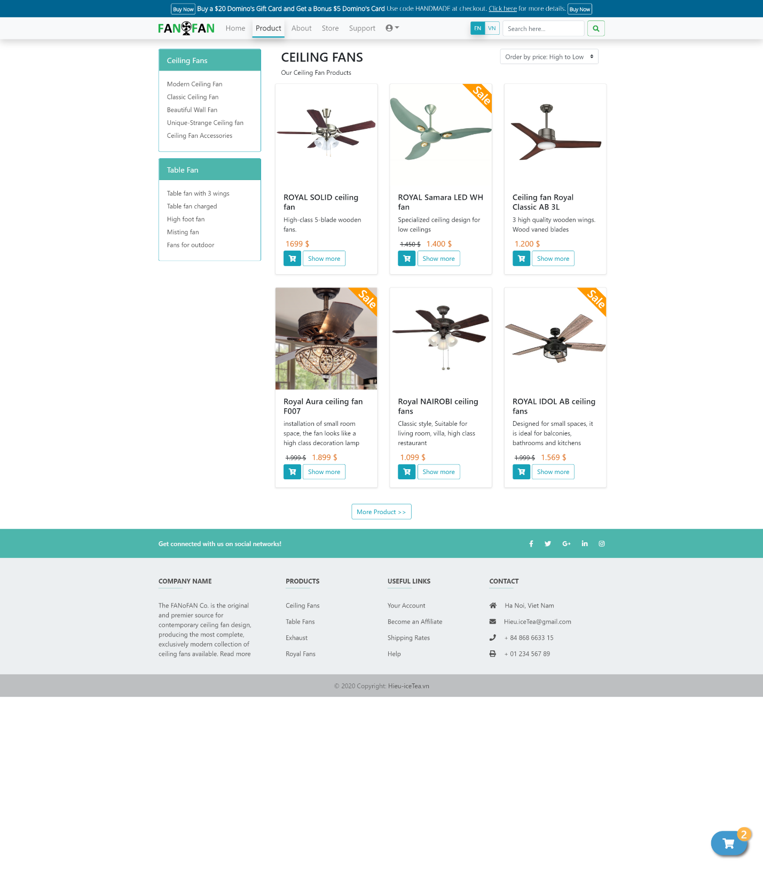

5.10,Support

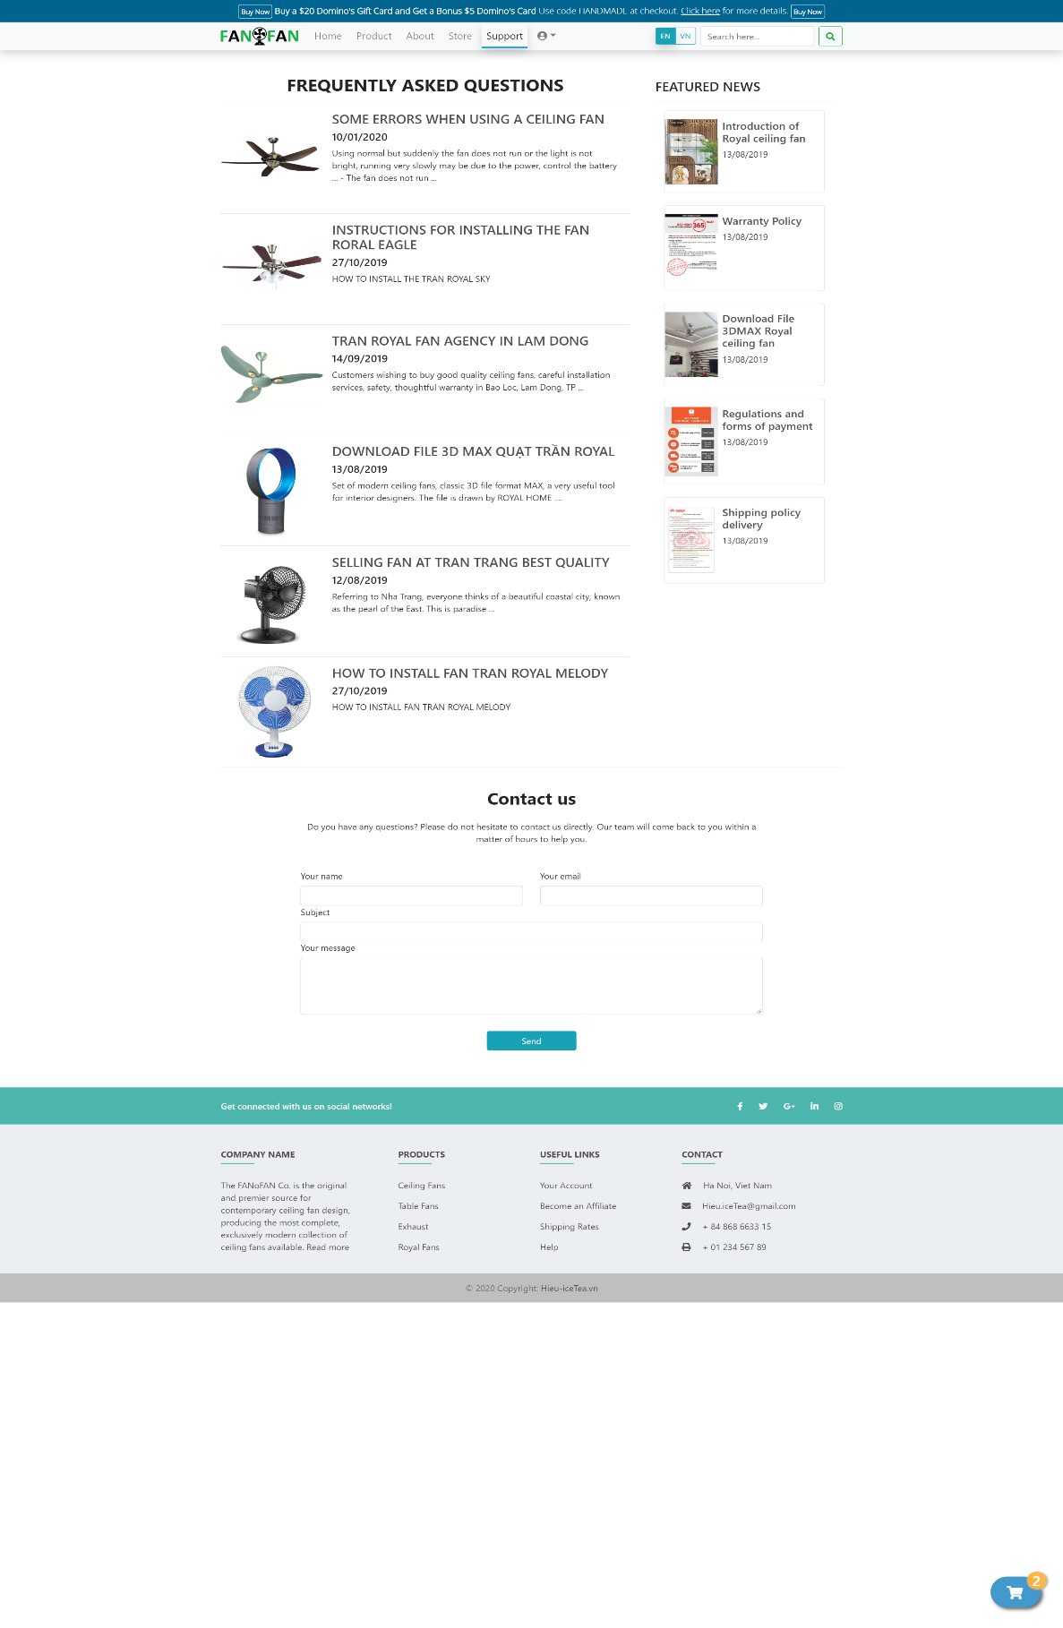

5.11,Sign in

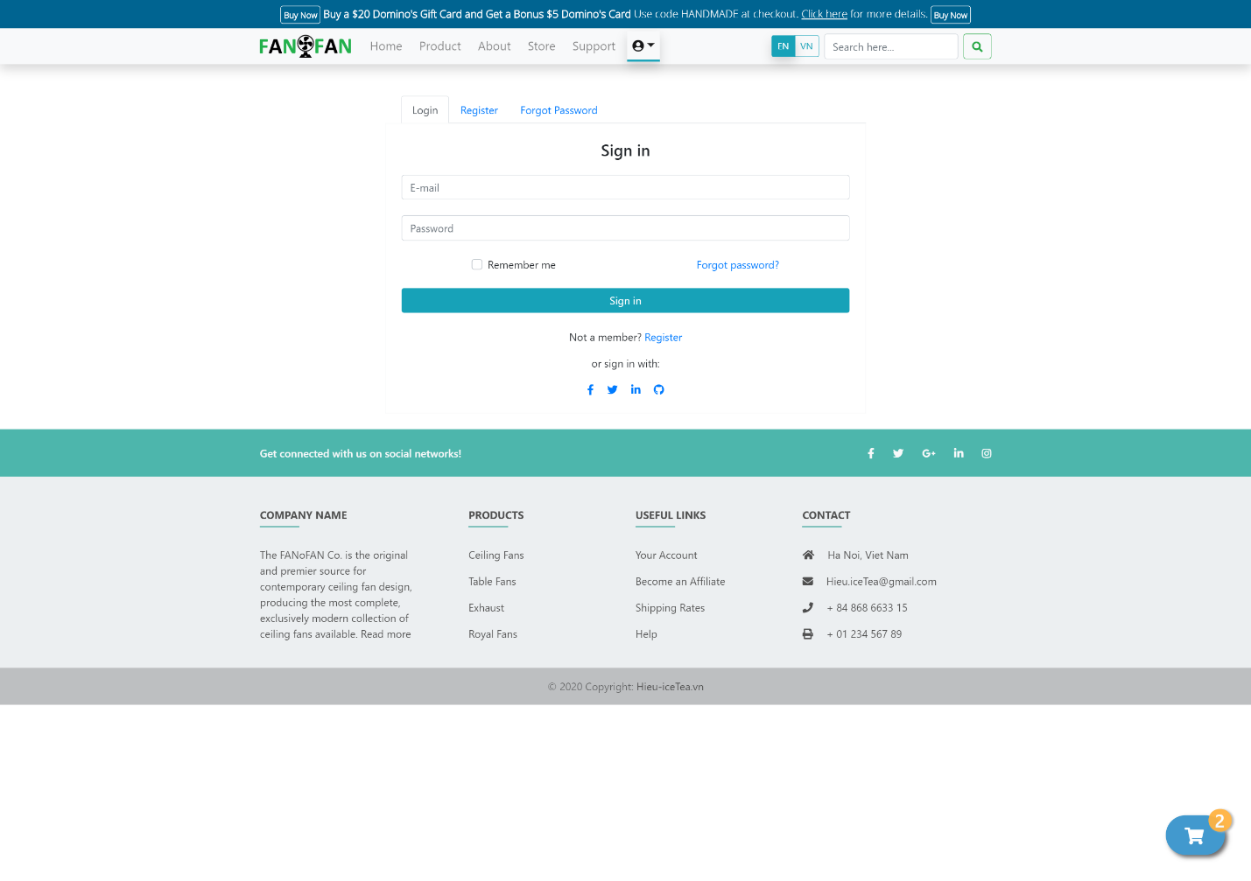

5.12,Sign up

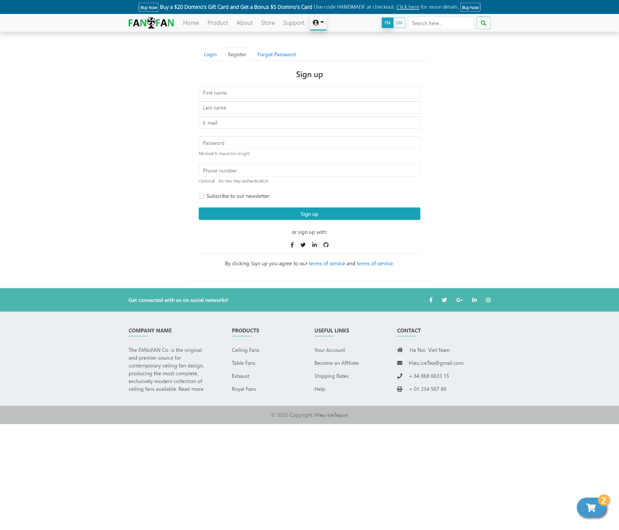

5.13, Forgot Password

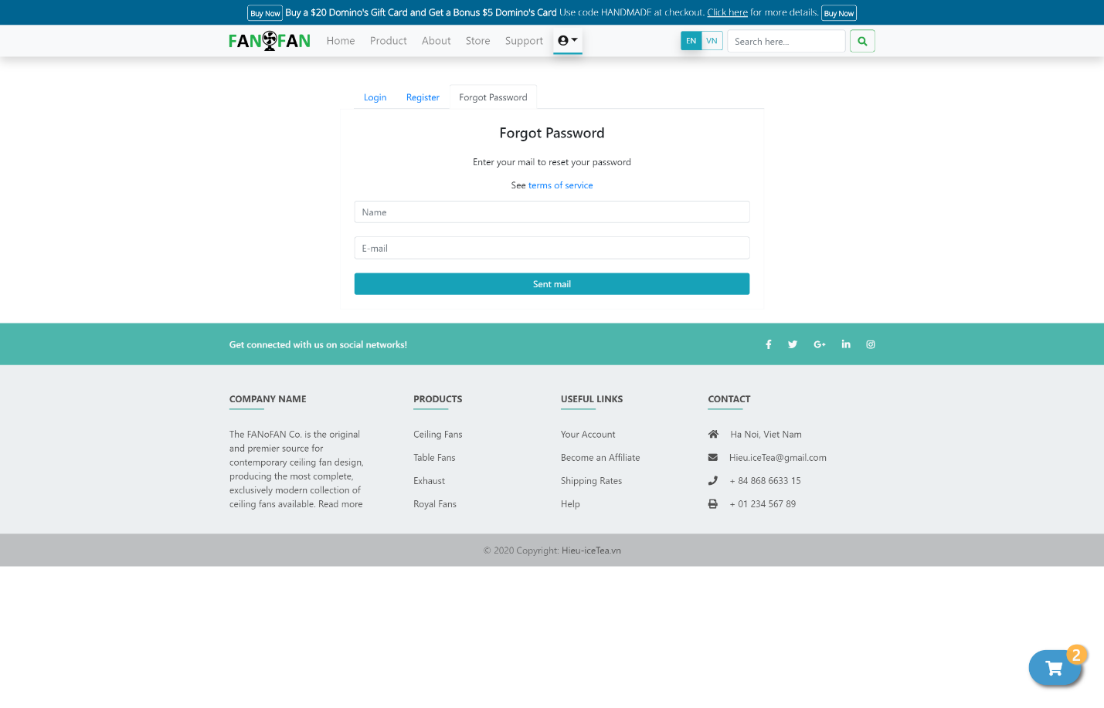

6.**Summary**

|  |  |  |  |  |  |
| --- | --- | --- | --- | --- | --- |
|  |  | Nguyen Dinh Hieu | Vu Quang Huy | Le Thanh Tung | Pham Tuan |
| 1. | Header (Menu Nav) | x |  |  |  |
| 2. | Footer | x |  |  |  |
| 3. | Home | x |  |  |  |
| 3. | Product-list |  | x |  |  |
| 4. | About |  |  | x |  |
| 5. | Store-list |  | x |  |  |
| 6. | Support |  |  |  | x |
| 7. | Product-detail |  |  |  | x |
| 8. | Cart-shipping |  |  | x |  |
| 9. | Write a report |  | x | x | x |
| 10. | Powerpoint report | x |  |  |  |